# **High Level Steps**

NOTE: These is just the high-level steps. A detailed breakdown of the steps is below. Move on to page 2 and follow the steps close.

**Setup SQL Developer**

1. Set up an oracle account and confirm account
2. Download sql_developer and install it

**Setup McCombs Oracle Server Connection**

1. Create McCombs Account and connect to server.

**Create tables and seed data**

1. Need to run the script in the client to create the tables. (Mccombs_db_setup folder)
   1. Run Create_ap_ex_om…. script. (Run as a script. Hit F5)
   2. Run VERIFY_ap_ex_om…. script. (This reports run numbers in newly created tables)
      1. One you complete the verify step, go complete the pre-class survey which will ask you to provide the counts you got to check you did things right.

## **SQL Developer Setup Steps**

**Step 1:** First go to [www.oracle.com](http://www.oracle.com) and create an account. You will find a tab at the top of screen where it reads “Sign in” and the pull down menu will allow you to choose Create Account.

**Step 2:** Use any web browser, search for “oracle sql developer download”.

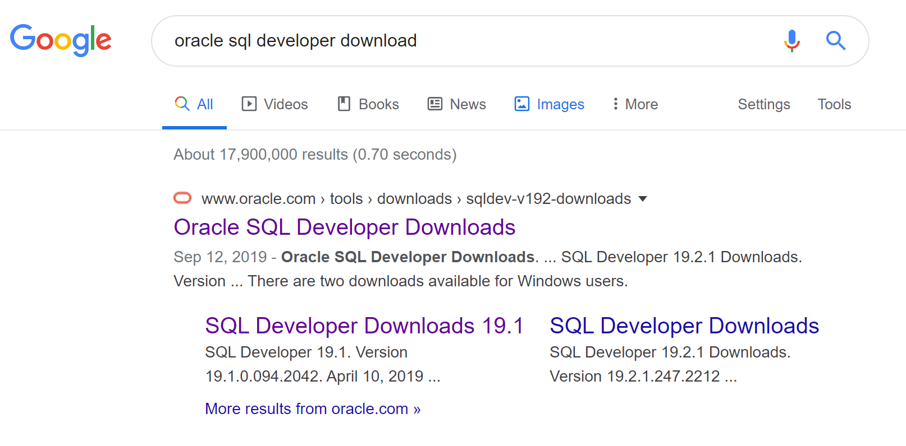

Click on the first link to get to the following landing page. Click on “Accept License Agreement”. Download the the right version that matches your operating system. If you’re unsure if your PC is 32-bit or 64-bit, go to your Control Panel and double click on “System” to see what version of system you have. If you have a 64-bit system chose the 64-bit with JDK version to download. Note: Download whatever the most current version is.

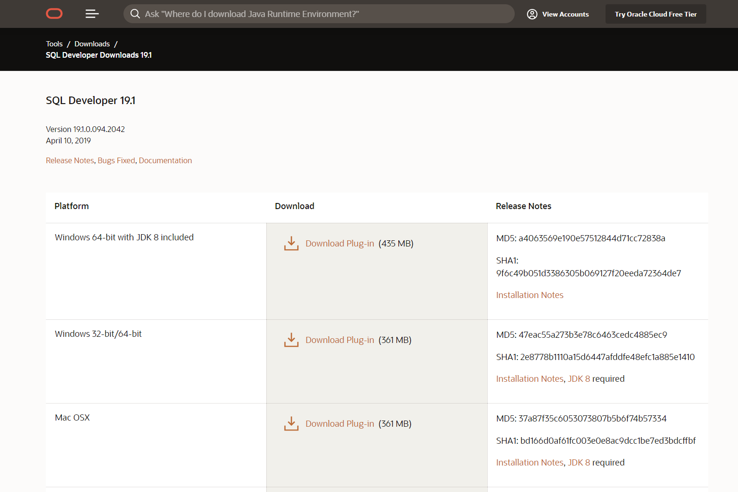

Once you click the download link, you’ll likely be prompted to log into your Oracle account. This is required to start the download of the sql developer zip file. Heads up, the download can take a while so start the process when you’re have a bit of time. You’ll get a zip file named something like “sqldeveloper-17.2.0.188.1159-x64”. Once downloaded, Install SQL Developer by unzipping (aka extracting) it. (Recommend unzipping into the C:\Program Files directory on a Windows system.), you’ll get a folder named “sqldeveloper” which contains the following files and subfolders. NOTE: The extract will take several minutes.

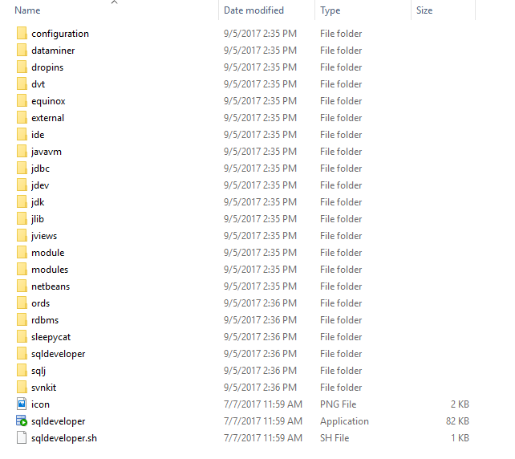

Now you can start SQL Developer by double clicking the **sqldeveloper** file as shown above. The startup page looks like the figure below. (You may want to create a shortcut for the **sqldeveloper** file and add it to the Start menu or desktop for easy access.)

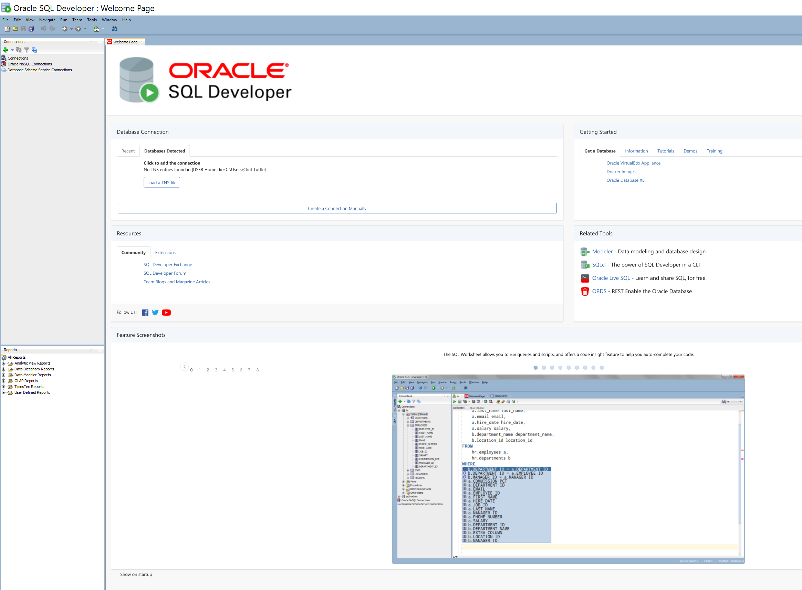

## **Setup McCombs Oracle Server Connection**

**Step 1. Setup password for your McCombs Oracle database server account.**

The official, McCombs way to initialize all Oracle Database server passwords is to use this web page:

<https://secure.mccombs.utexas.edu/missqlpwdchange/default.aspx>

Select “*Server for Tayfun Keskin’s MIS381 Class (msb-msba.austin.utexas.edu)*” from the drop-down menu. Then, set your password by following the password requirements on the website.

**Step 2. Establish a connection to your McCombs database server.**

Start the Oracle client program (SQL Developer). Establish a connection to the McCombs database server by click New Connection (the plus sign).

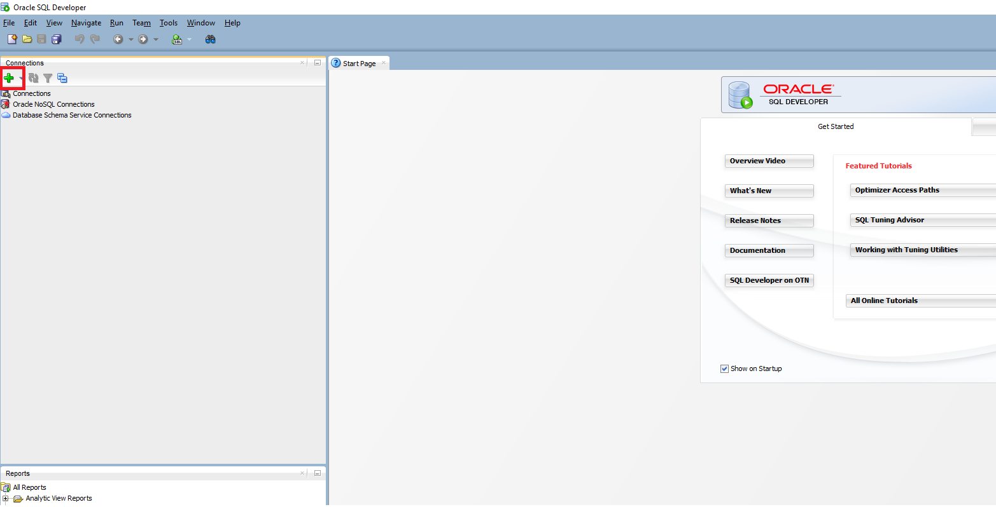

You will be prompted to enter the definition of the new database connection. Enter the following information:

**Connection Name**: This can be whatever (e.g. My 381 Server Connection) *

**User Name**: <Your UT EID>

**Password**: <the password that you have initialized above in Step 1>

**Connection Type**: Basic

**Role**: Default

**Hostname**: *msb-msba.austin.utexas.edu*

**Port**: 1521

**SID**: ORCL

*This is whatever you want to save the connection name for later use.

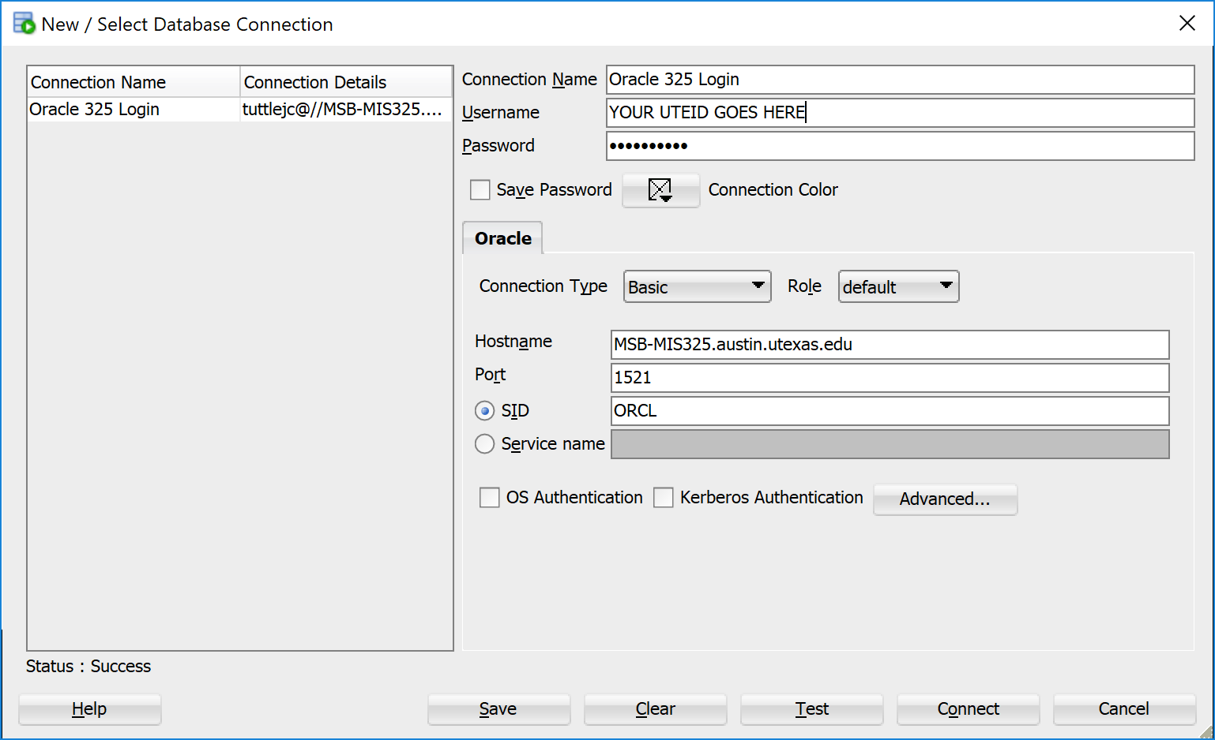

At this point, you should see the newly connected server on the left side of the screen. Expand it to view the contents of your database space on the server. A SQL worksheet also automatically opens on the right side of the screen, which can be used to write SQL commands.

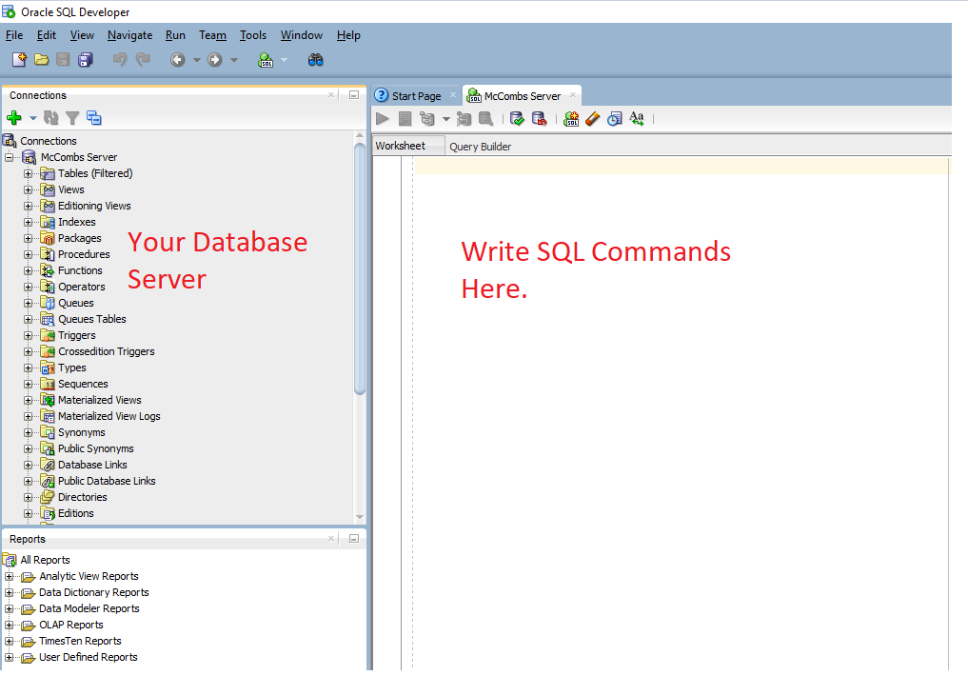

## 

## **Create Tables and Seed Data**

Download the three files from the Pre-Class Preparation section of the DDL Class module This is the same page you download these instructions.

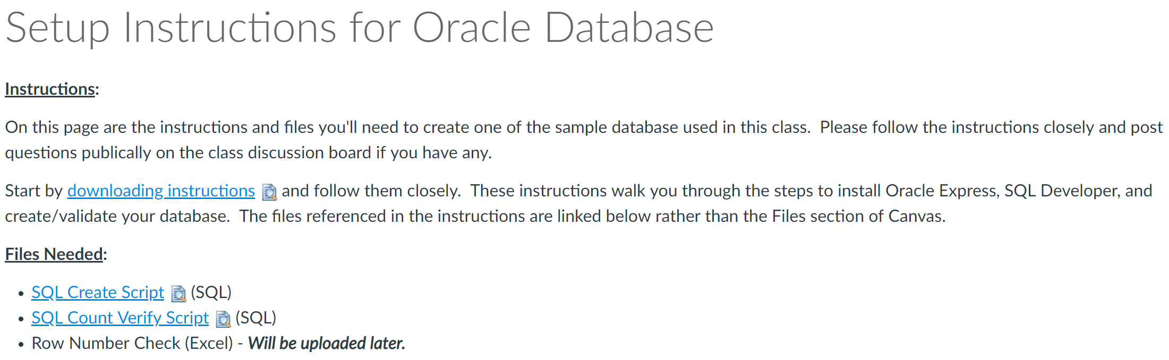

Open the file CREATE_ap_ex_om_mgs_tables.txt, copy everything in the file to the SQL Worksheet (refer to the last figure in Step 2, where it says “Write SQL Commands Here.”).

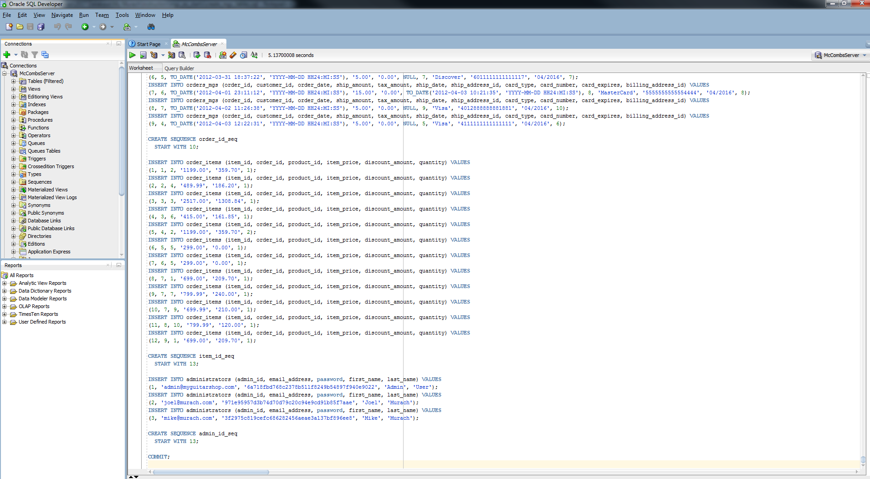

Execute this script by clicking on the Run Script button or press the function key F5.

When it’s done, you should be able to see all the tables on the left by clicking the plus sign before the node *Tables*. (Right-click on Tables, then click on Refresh if tables are not there.)

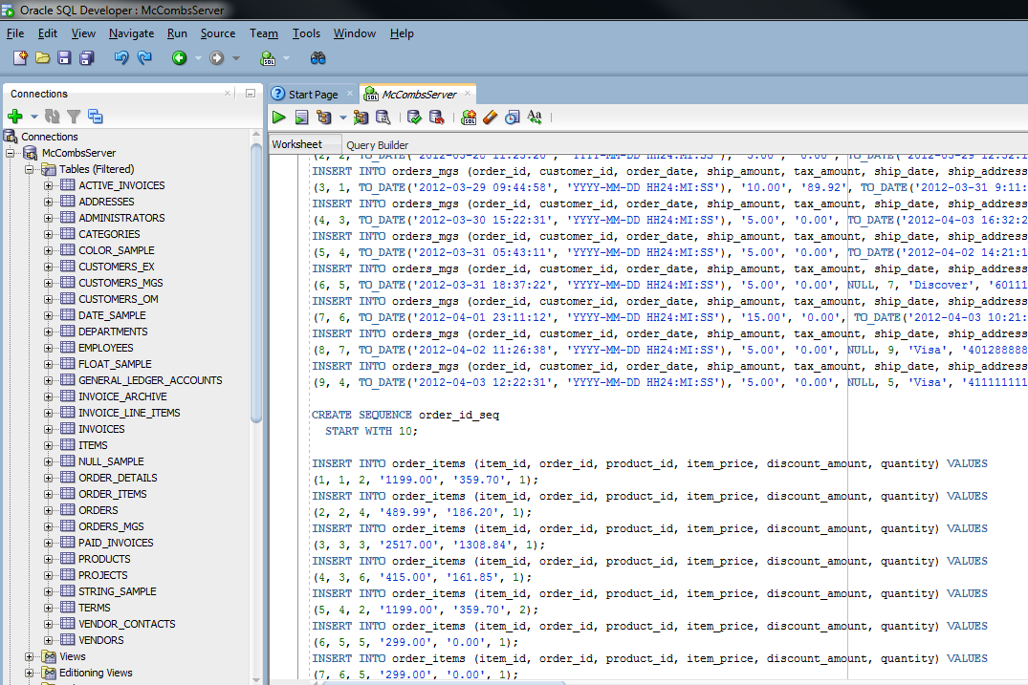

Delete the script in the SQL Worksheet (or open a new Worksheet by click the SQL Worksheet button), open the file VERIFY_ap_ex_om_mgs_tables.txt, copy everything in the file to the empty SQL Worksheet, and execute the script by clicking on the Run Script button or press the function key F5. The result in the Script Output shows number of records in each of the 29 tables you just created. Now you can verify whether you have done everything right by comparing the result to the third file Row_counts.xlsx you downloaded from Canvas.

